|  |  |
| --- | --- |
| **Name** | **Muhammad Asad** |
| **Roll no** | **2019ee383** |
| **Section** | **A(G1)** |

**Programming Fundamental**

**Lab no 9**

**Objective:**

In this lab, I will able to use of loops in C language. I will solve some problems using different loops such as for loop, while loop and do while loop.

**Task #01**

* Write a program using while loop that keeps asking the user to enter a number until -1 is entered.
* Then displays the number values entered, the sum of all the entered number and its average.

**Code:**

/*I will calculate average of the numbers entered and its sum.*/

#include <stdio.h>

int main(void){

/*Here I declare a variable.*/

int number;

int counter;

int sum=0;

double Average; /*I declare float variable*/

printf("enter a number ");

scanf("%d",&number);

//Here I use while loop.

while(number!=-1)

{

sum=sum+number;

printf("Sum is %d\n",sum);

printf("enter a number ");

scanf("%d",&number);

counter++;/*count=count+1;*/

}

printf("count is %d\n",counter);

Average=(double)(sum/counter);/*This is the farmula for Average*/

printf("average is %f",Average);/*%f shows average is floating value. And print Average hear*/

return 0;/*this shows that program is ended*/

}

**Output:**

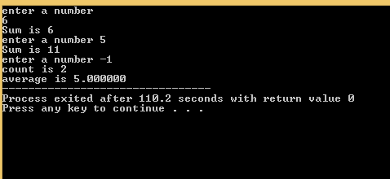

**Task no 2**

* Write a program using while loop that asks a user to enter the total number of students enrolled in Computer Programming class.
* Then asks the user to enter the marks obtained by each student in this class.
* Display the average marks obtained.

**Code:**

#include <stdio.h>

int main(void){

/*Here I declares three variables and

one object of integer data type and

one float variable.*/

int total;

int number;

int count=1;

int sum=0;

float average;

printf("enter the total no of students ");

//Here I enter a number from user.

scanf("%d",&total);

//Here I use while loop.

while(count <= total)

{

printf("enter the number ");

scanf("%d",&number);

if(number>0 && number<=20){

sum+=number;

printf("Sum is %d\n",sum);

//count=count+1;

count++;

}

//Here I calculate average.

average=(float)(sum/count);

printf("average is %f",average);

return 0;

}

**Output:**

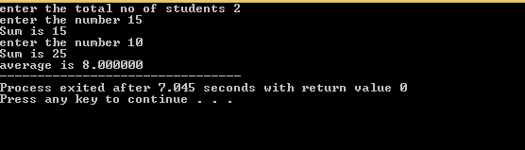

**Task no 3**

* Write a program which computes the factorial of a positive integer using do-while loop.
* N factorial is: n!=(n)(n-1)(n-2)(n-3)….(3)(2)(1)

**Code:**

#include <stdio.h>

int main(void){

int number=3;

int count=1;

int factorial=1;

//Here I use do while loop.

do

{

factorial=factorial*count;

printf("%d\n",factorial);

count++;

}

while(count<=number);

return 0;

}

**Output:**

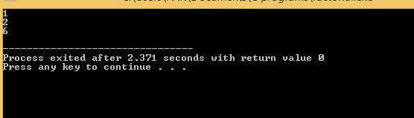

**Task no 4**

* Write a program using do-while loop that print the first 20 prime numbers which are not divisible by 3

**Code:**

#include <stdio.h>

int main(void){

int number=1;

int count=1;

do

{

if(count%2!=0 && count%3!=0)

{

printf("%d\n",number);

count++;

}

count++;

}

while(number!=0);

return 0;

}

**Output:**

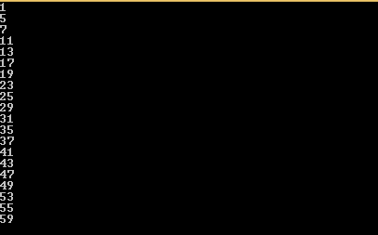

**Task no 5**

* Write a program using for loop which displays the table of entered number.(1-20).

**Code:**

#include <stdio.h>

int main(void){

int x;

int y;

int total;

printf("enter a number ");

scanf("%d",&x);

for( count=1; count <=10; count++ )

{

printf("%d * %d=%d\n",x,count,x*count);

}

return 0;

}

**Output:**

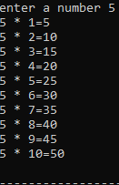

**Conclusion:**

In this Lab I able to do a program and successful in correct Output.